Industry Live – 4 Nov 2020 – 1pm to 2pm AEDT
Job interviews – How can I calm my nerves and nail a job interview? Professional advice on dress code, questions you might be asked and how to make sure your resume hits the mark.

Our panellists:
Lara from HAYS Recruiting – Lara is an experienced HR professional who works for HAYS, the biggest recruitment firm in Australia and New Zealand. Lara specialises in IT, HR, office and contact call centre recruitment and will share her advice on how to land that job of your dreams – from what to expect at interview to how to prepare that job-winning resume.

Narelle from Cummins – Narelle is the Asia-Pacific talent acquisition leader for Cummins Inc. Cummins is a global company that designs, manufactures, sells and services diesel and alternative fuel engines. Narelle has more than 20 years’ experience in HR and recruitment and will share with students exactly what large companies are looking for when recruiting field and office staff, and how you can avoid some common mistakes at your next job interview to stand out from the crowd.

Taryn from Dress for Success. Dress for Success is an international organisation that offers advice on how to build confidence and achieve employment goals by matching your dress style to the job you want. Hear first-hand from a style expert about what you should be wearing to your next job interview to maximise your fit for the job.

Help inform our Industry Live program 2021!
Tell us what topics you’d like to see by completing our short online survey
at the link below.

https://www.surveymonkey.com/r/XGPYHGL

Dress for Success
Advice below from Taryn from Dress for Success Hobart
Dressing for trades, apprentice, field jobs (known as “blue collar” jobs)
Dressing for job interviews for office-based or professional jobs (known as “white collar” jobs)

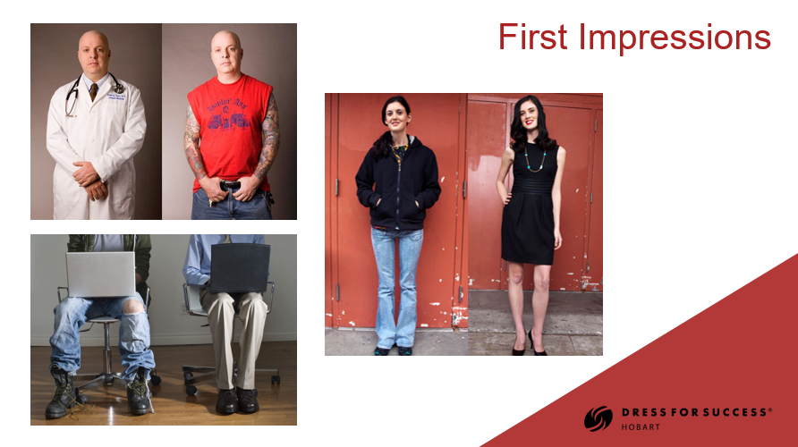

Dress recommendations for trade-based (“blue-collar”) jobs

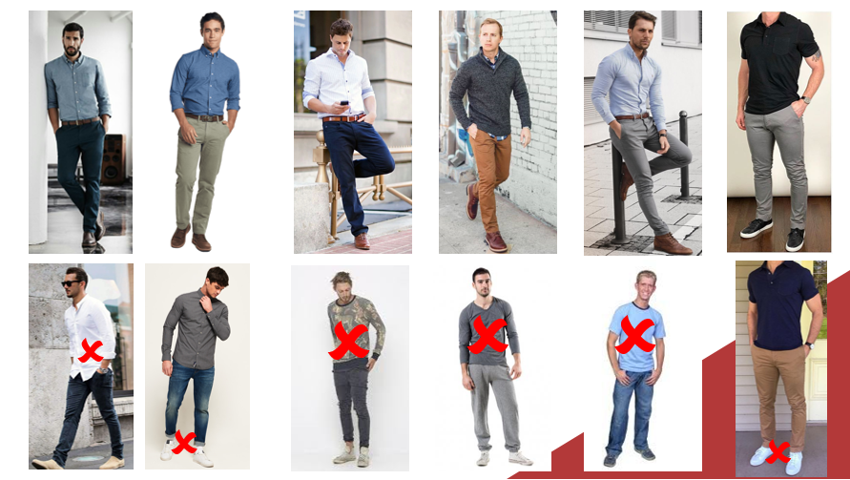

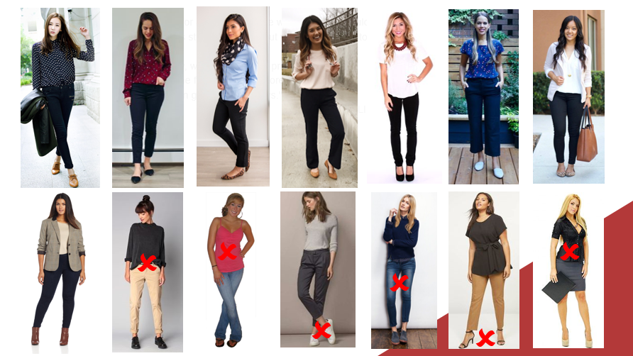

Dress recommendations for office-based (“white-collar”) jobs
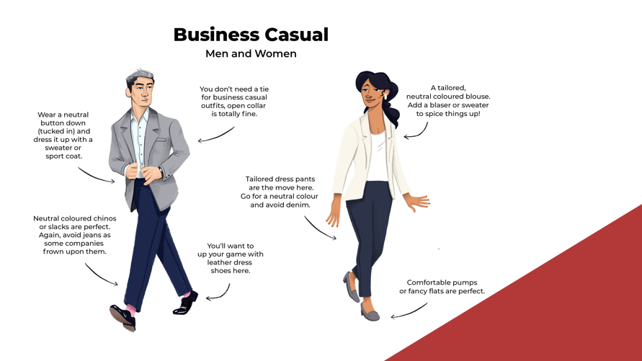

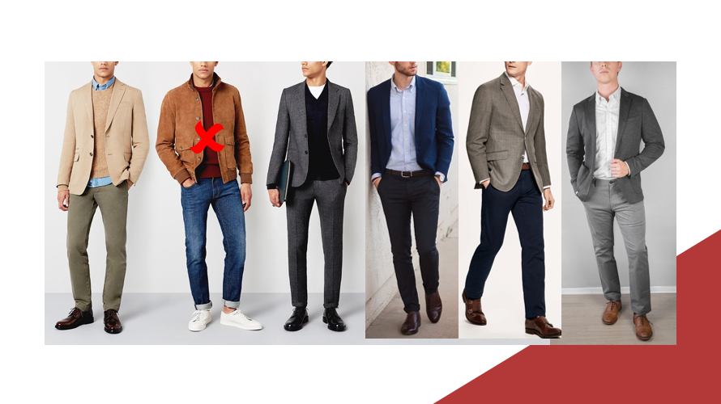

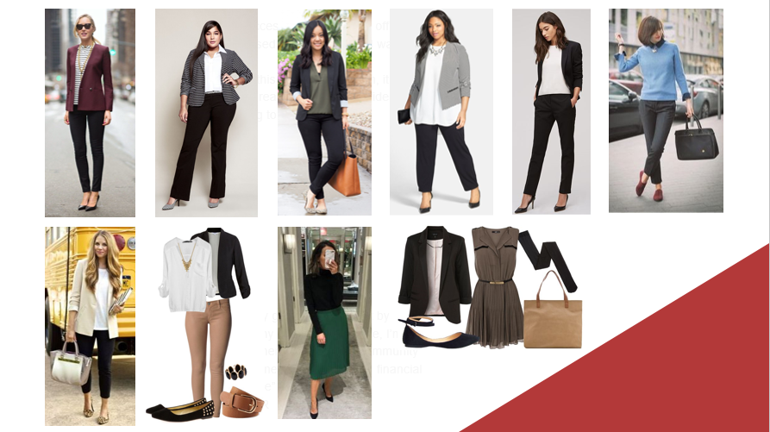

Sample resume – from Narelle from Cummins
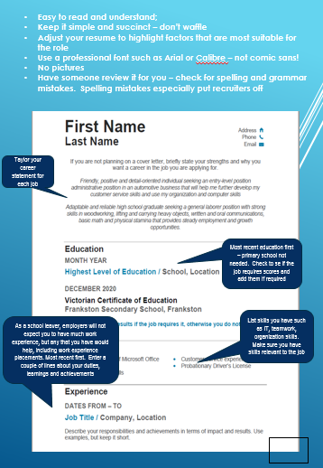

Click on the PDF below to open up the full sample resume

Advice from Narelle from Cummins
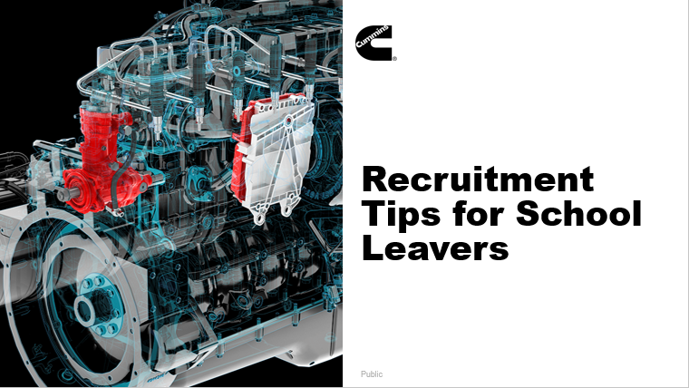

About Cummins
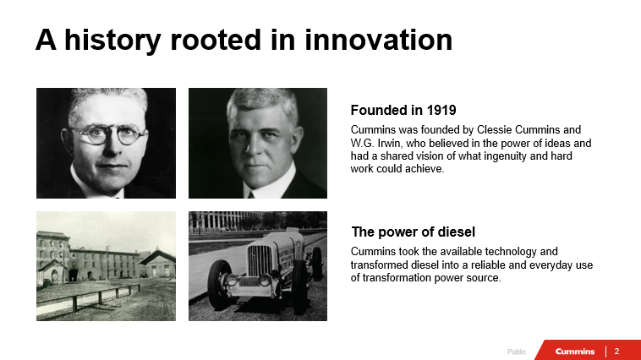

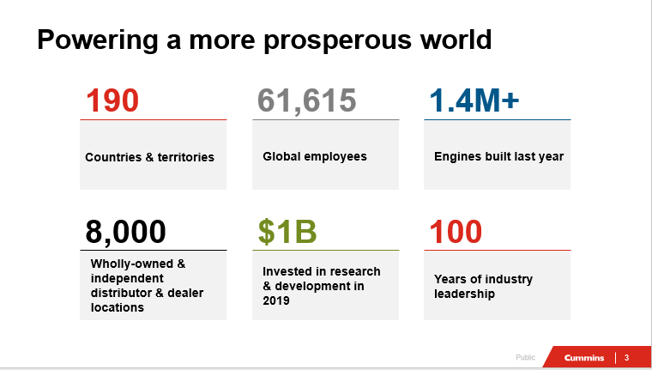

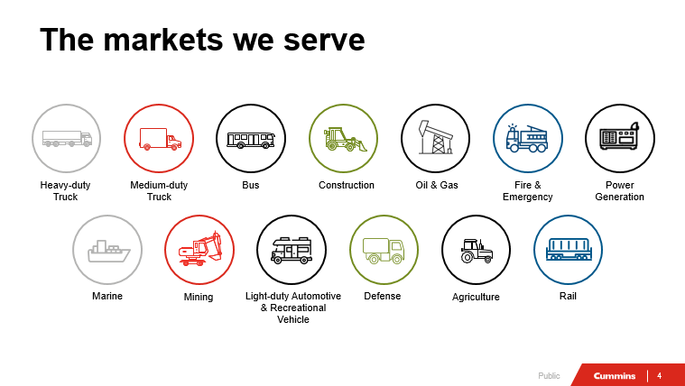

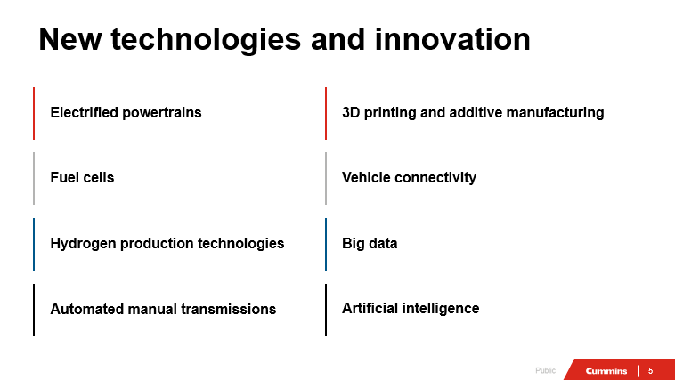

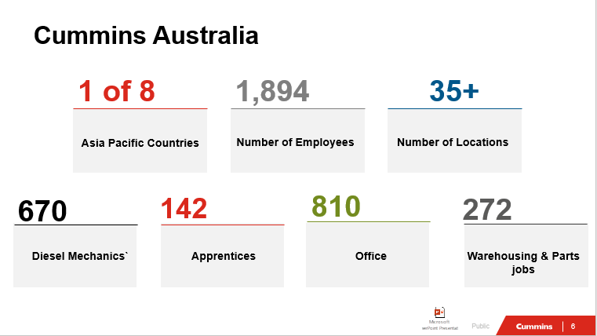

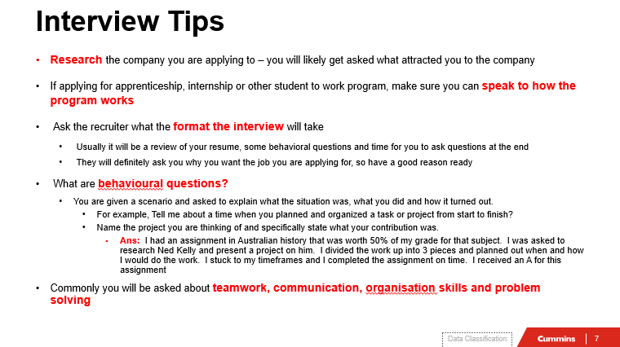

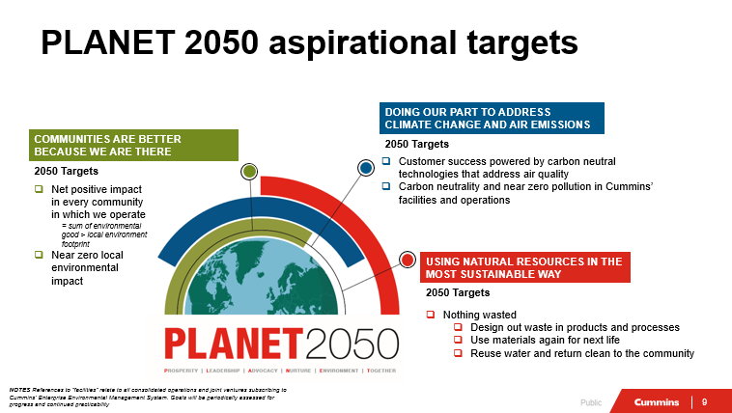

From Lara from Hays Recruiting – Tips for Online Job Interviews
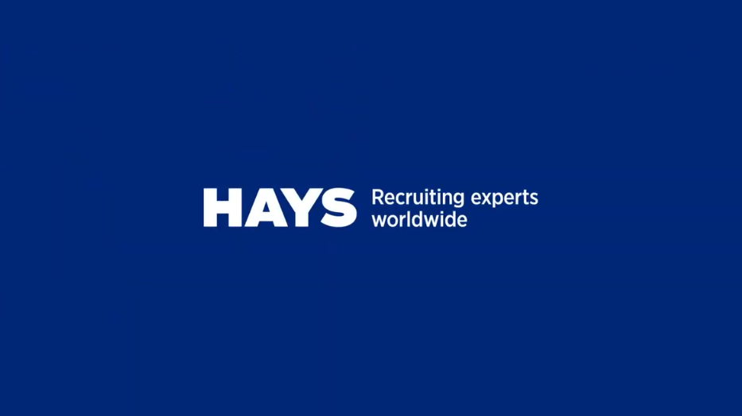

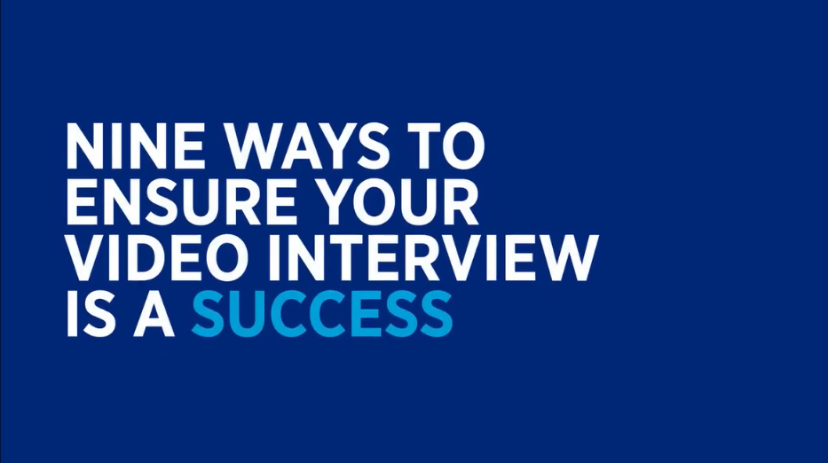
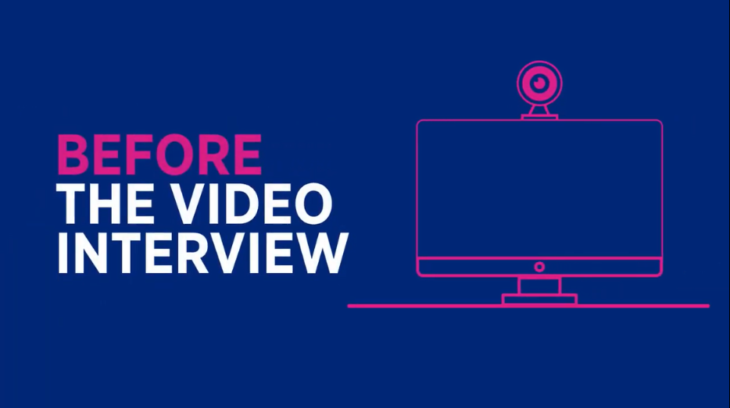

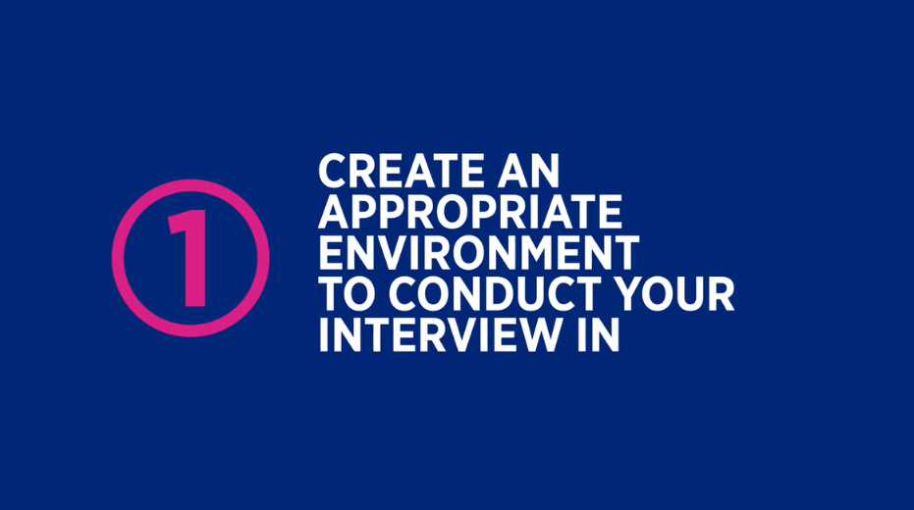

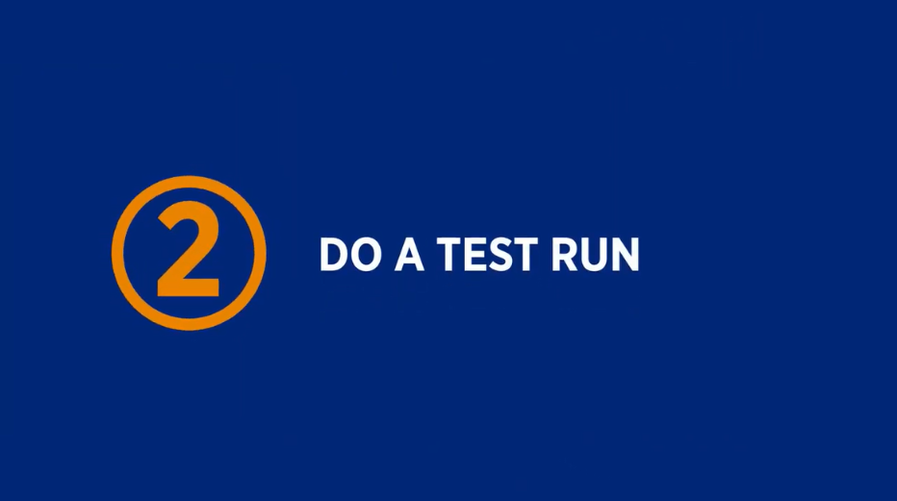
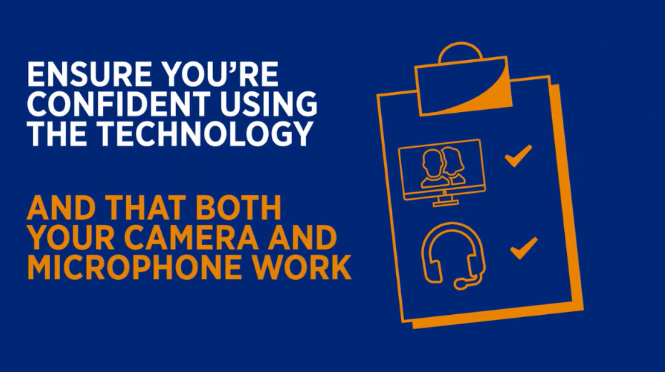

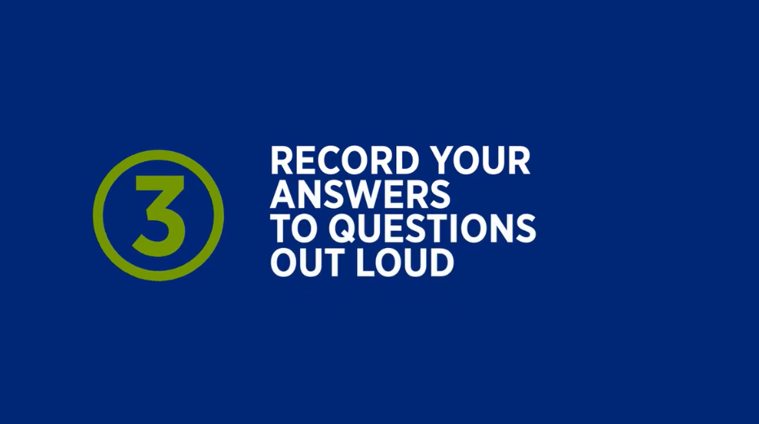

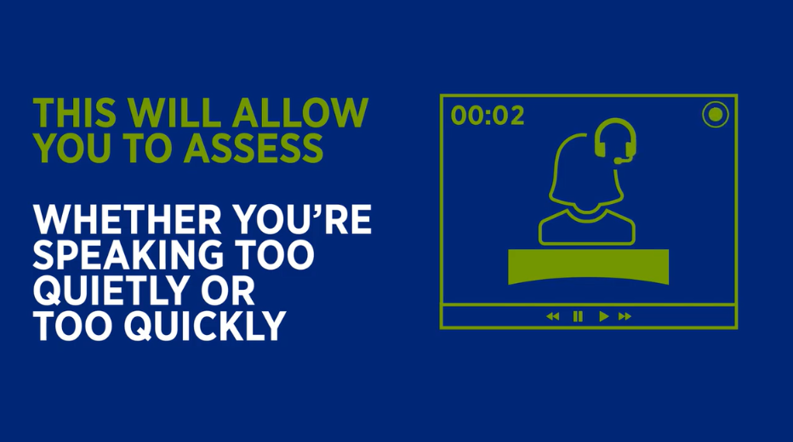

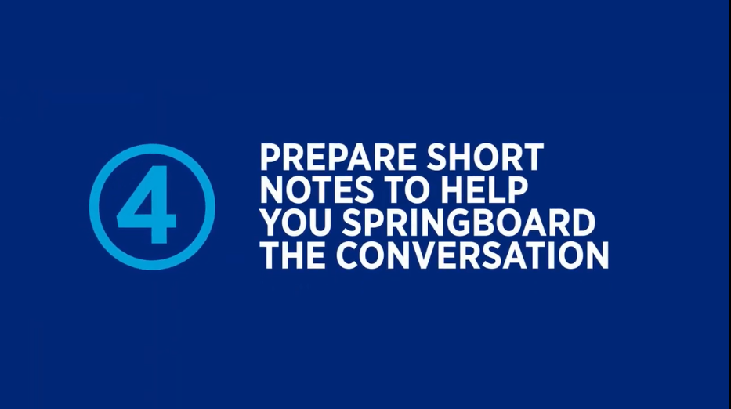

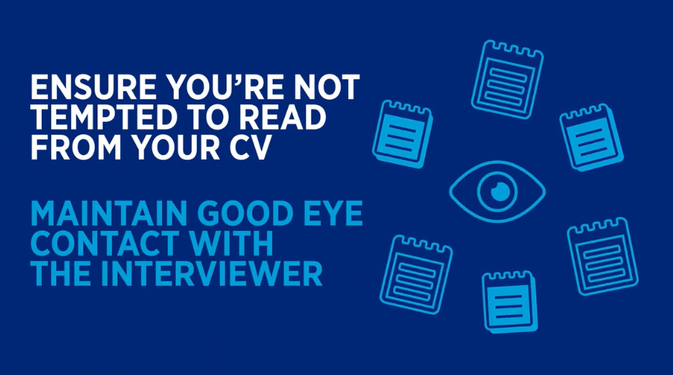
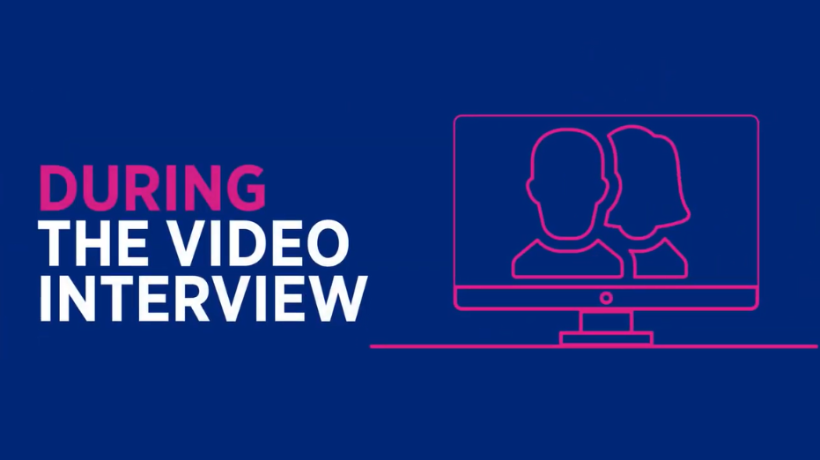

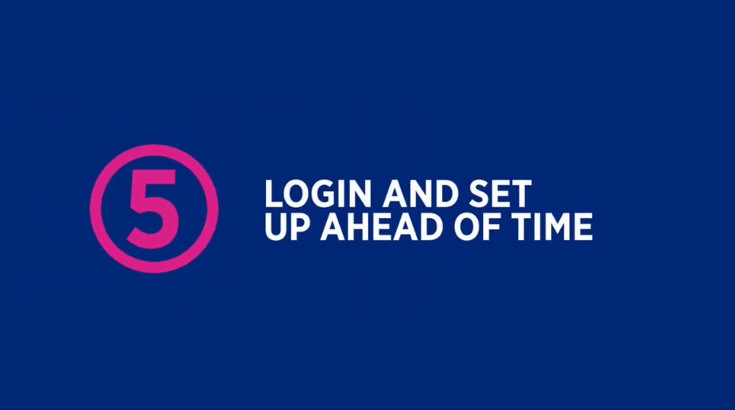

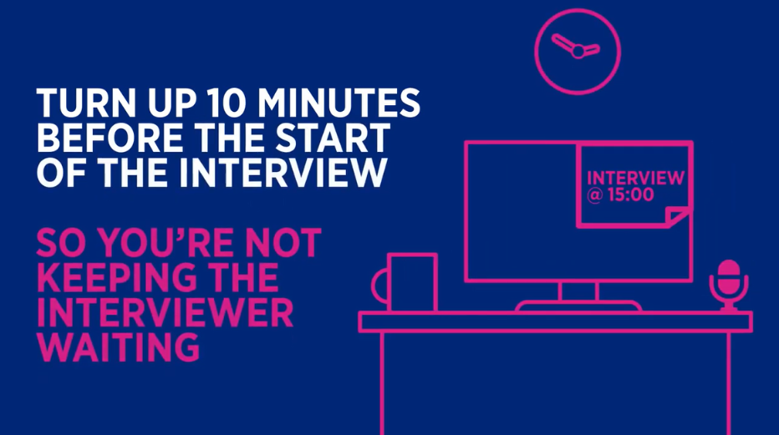

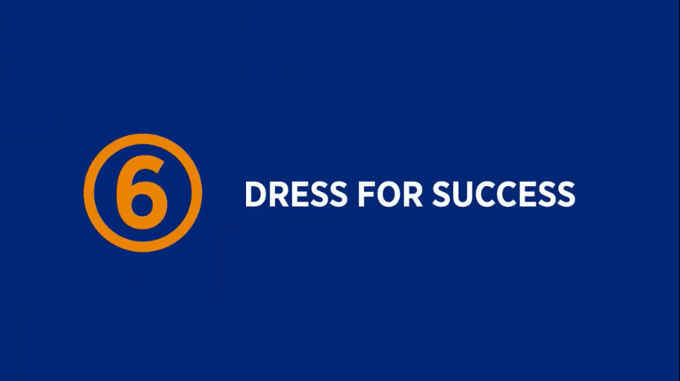

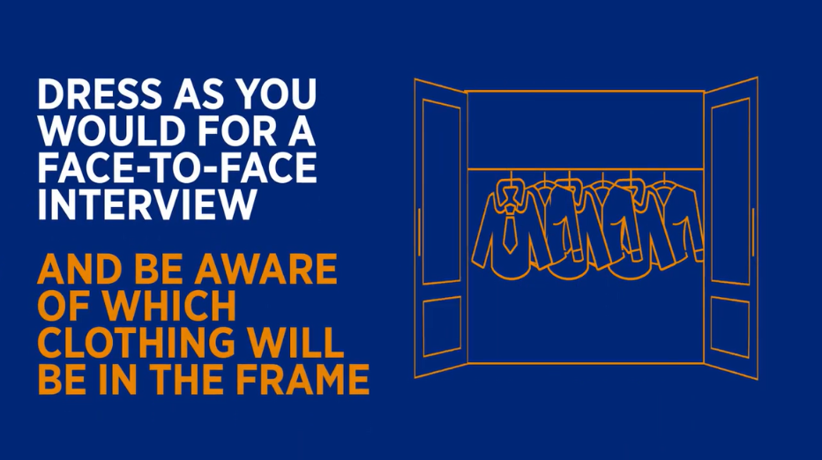

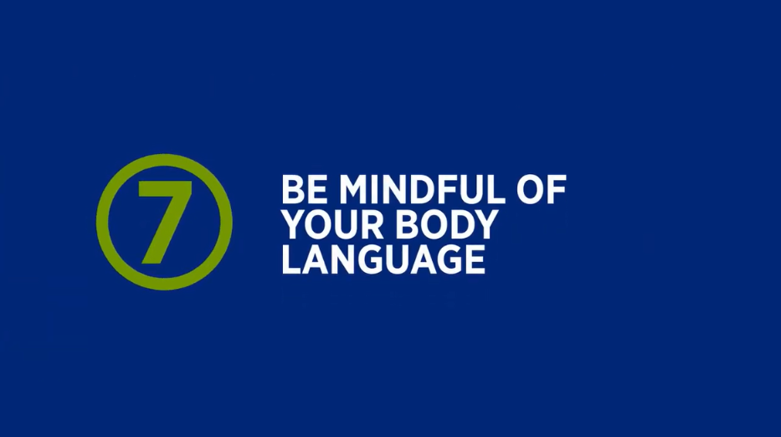

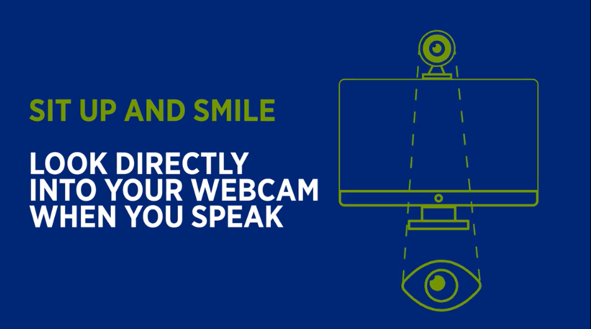

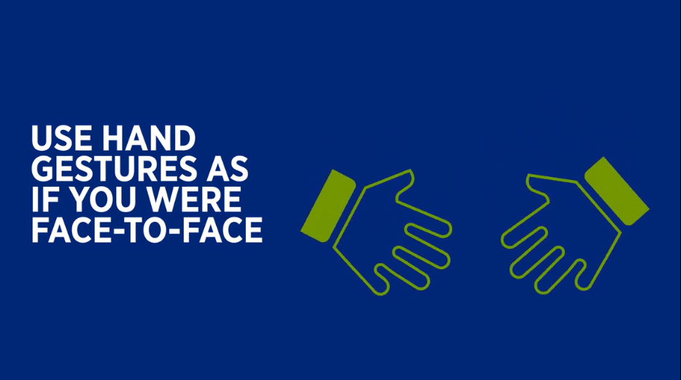

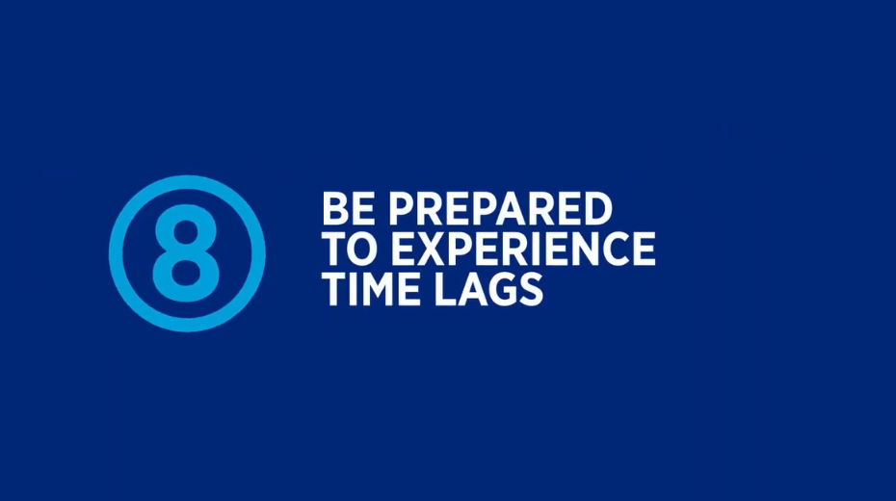

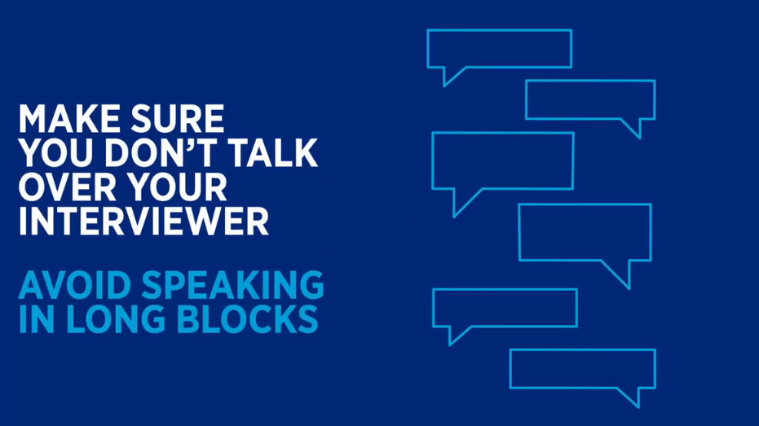

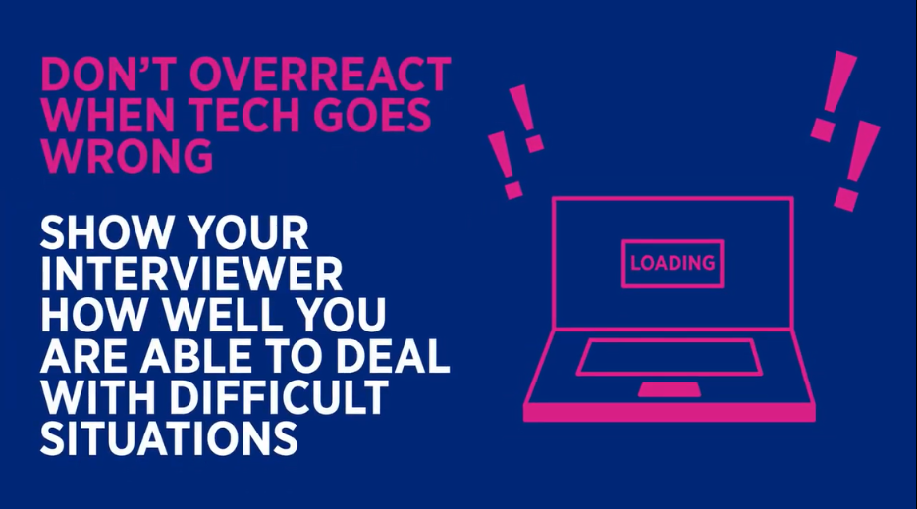

Final advice from our three panellists - Resumes

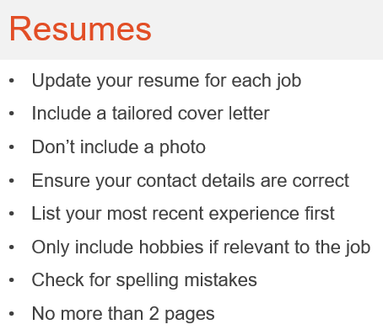

Final advice from our three panellists – Job interviews

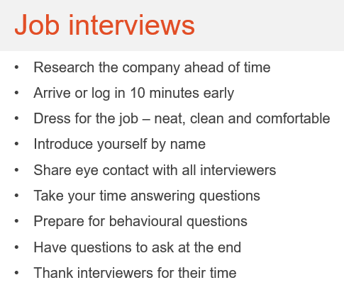

Company links
